For this post, we’re going to walk through the basic steps of setting up the Active Directory Domain Services (AD), Domain Name Services (DNS), and Dynamic Host Resolution Protocol (DHCP) services on Windows Server 2019. This is going to be just the basics for people new to setting up these services. I’m making a few basic assumptions for anyone who wants to walk through these steps. These assumptions are that the VM is already installed; the computer name has already changed to something more readable; and the server has been set with a static IP address.

To start, when you first boot up your server, the server manager should start automatically, and you should be looking at a screen like this. We’ll want to click on “Manage” in the upper right part of the screen.

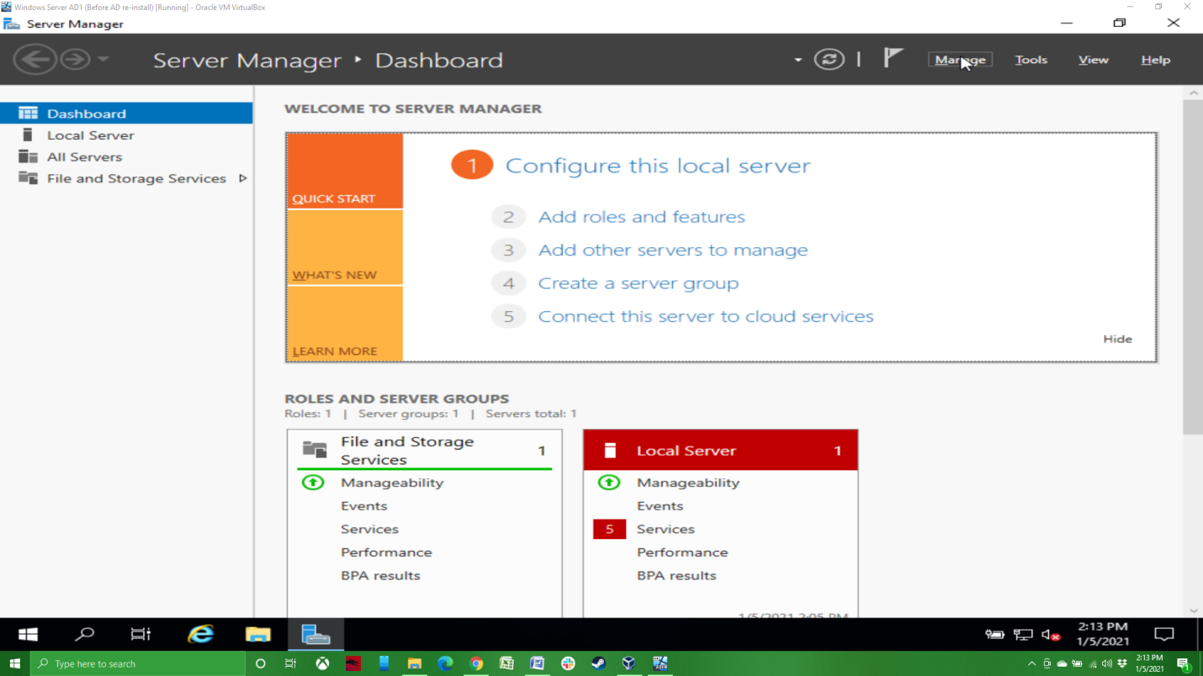

We’re then going to click on “Add Roles and Features”.

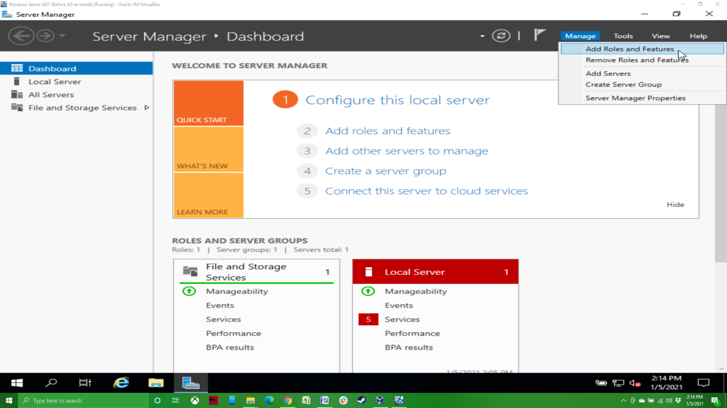

On the Before you Begin screen, just click next. Leave the Installation Type as Role-based and click next. You’ll then be on the Server Selection screen. If you have more than one server listed, make sure you click on the server you want to set up AD on. As you can see, I just have one server, which is highlighted, and so we can click next.

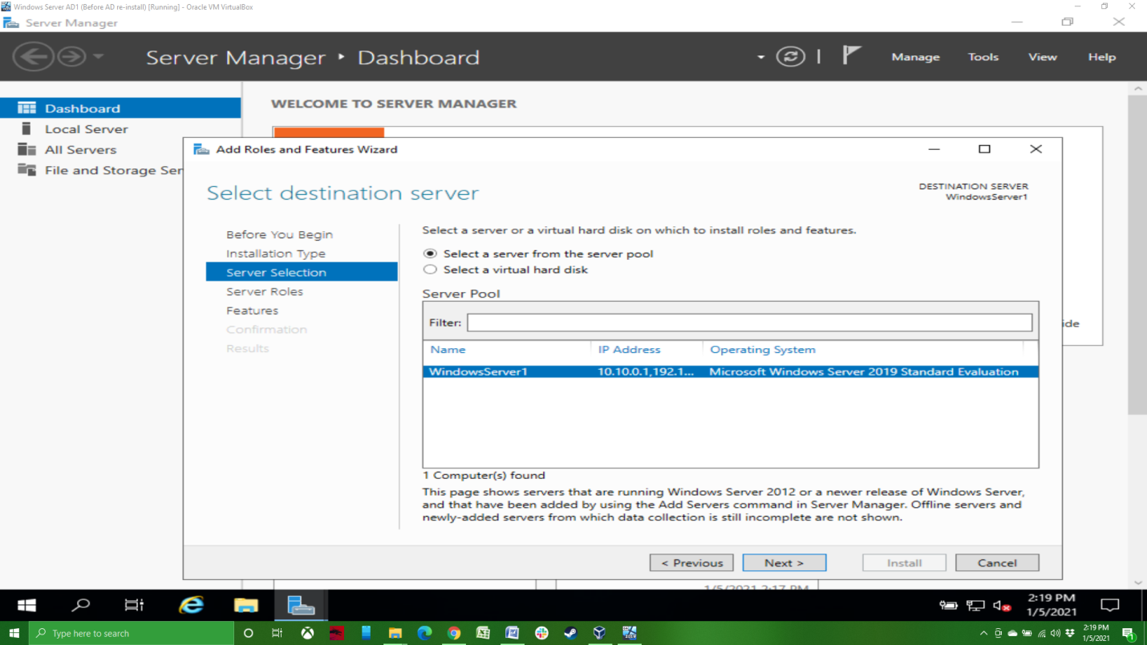

On the Server Roles screen, click on the Active Directory Domain Services check box. A confirmation screen will appear, click on Add Feature. Do the same for DNS Server. We’ll come back to DHCP later. It’s worth pointing out at this point that the primary Active Directory Domain Services server is required to also be set up as a DNS server. If you don’t add the DNS Server service, it will be automatically added. The automatic add is a change from older versions of Windows Server.

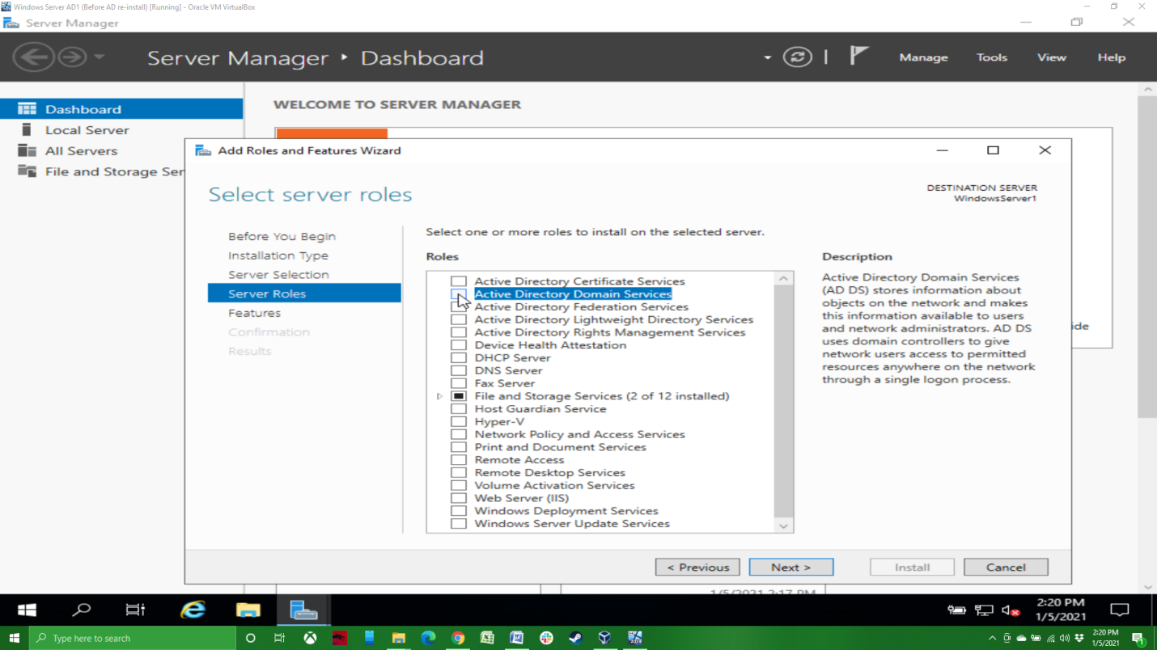

Nothing to do on the Features screen, I just want to point out that Group Policy Management is automatically checked as it is part of AD, so we can just click next.

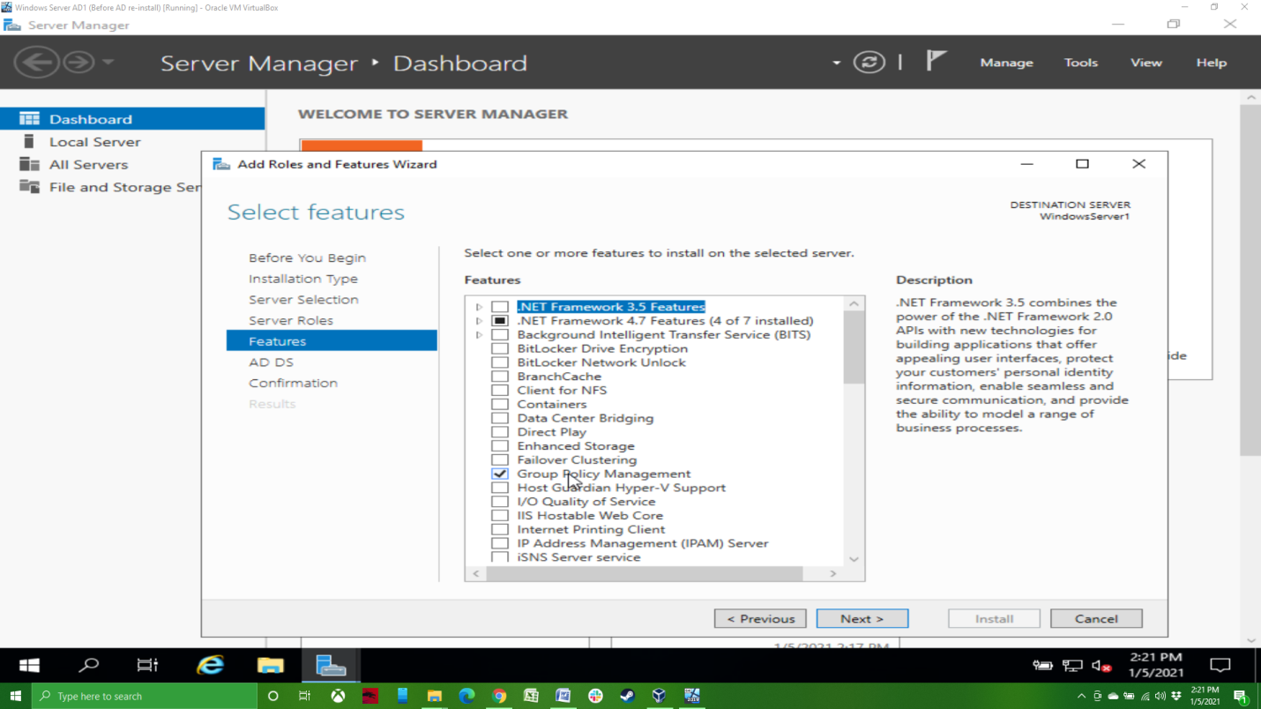

On the Confirmation screen, I like to click on the automatic restart check box, but you don’t need to. Click “Install”. This will likely take a little while, so feel free to go use the bathroom or refresh your drink.

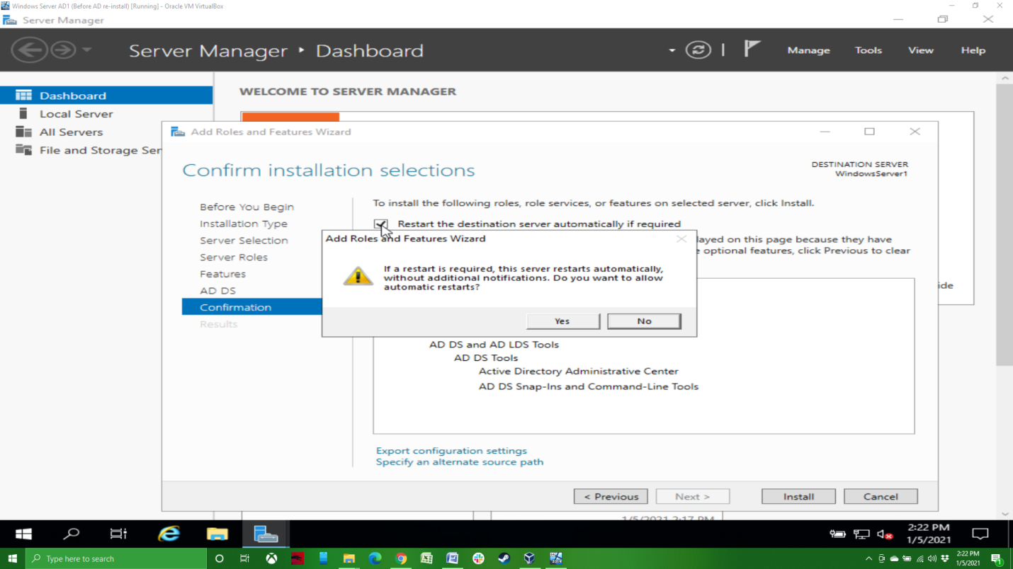

After AD and DNS have been installed, we’ll need to promote the domain controller to finish setting up AD. You can click on “Promote this server to a domain controller” in the main screen, or you can go to Notifications in the upper right.

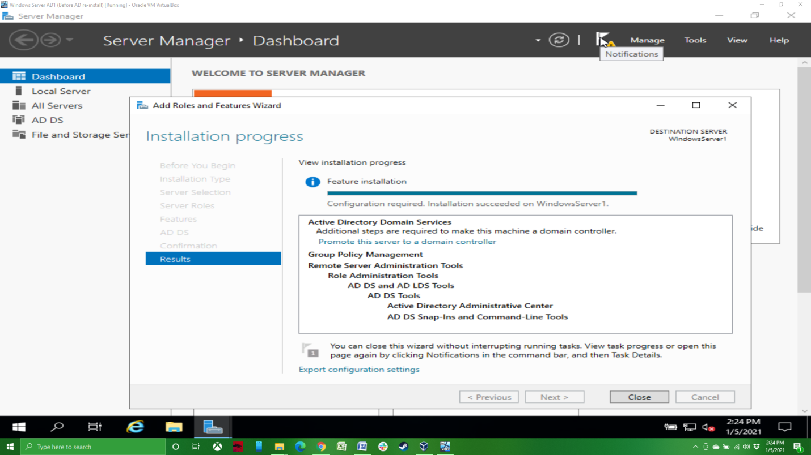

Click on Promote this server…

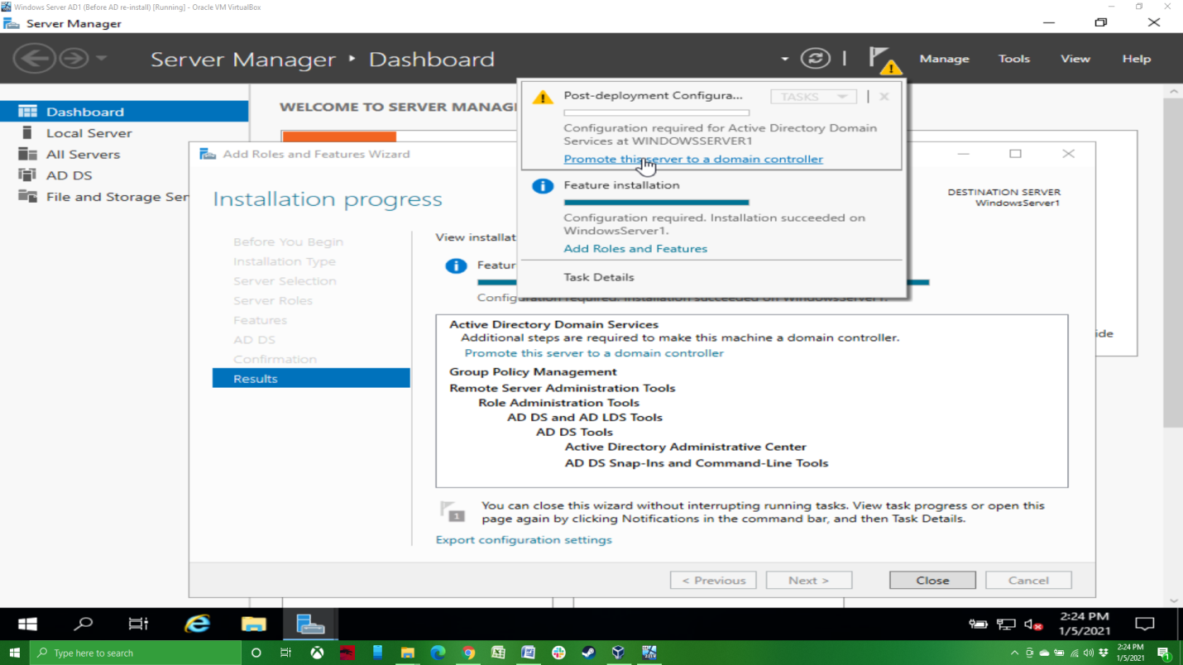

On the Deployment Configuration screen, since this is our first domain controller for the domain we’re creating, we’ll want to select “Add a new forest”. In the Root domain name field, you’ll need to add your domain name, which needs to be in the xxxx.xxx format. As you can see, I’ve entered home.net, but one could use home.com or home.org or company.com, etc. Keep it simple and relatively descriptive of the domain you’re creating.

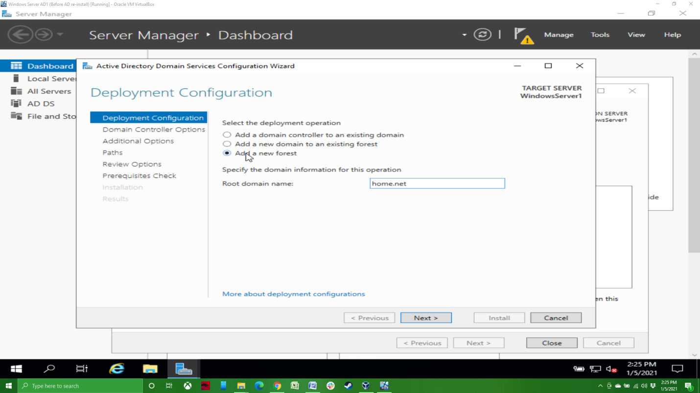

On the Domain Controller Options screen, make sure Domain Name System server check box is checked (it should be by default); then enter a password for Directory Services Restore Mode, then click next.

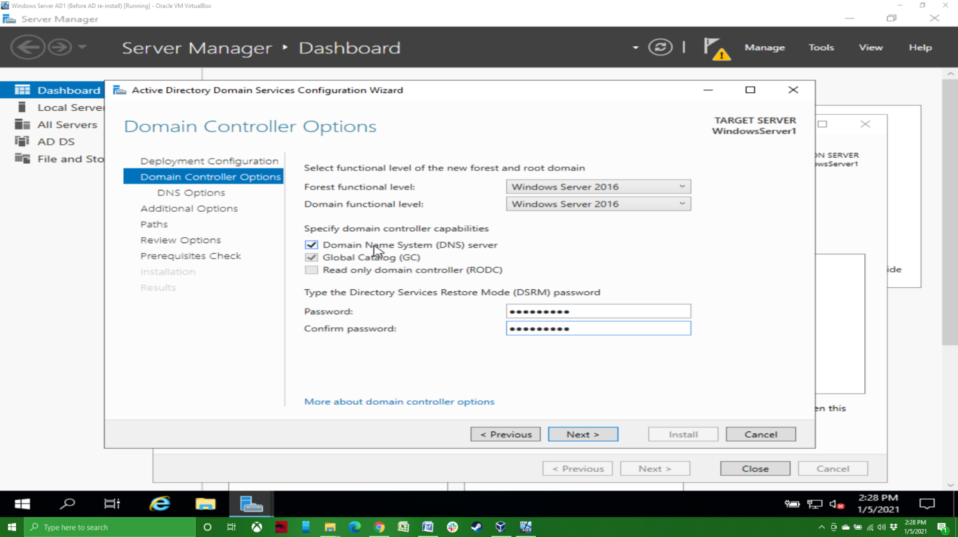

Click next under DNS options and as long as the NetBIOS domain name looks good on the Additional Options screen, click next. It should default to the given domain name, minus the .xxx extension. Click next on the Paths and Review Options screens. As long as you get the green check mark on the Prerequisites Check screen, you’re good to click install. This will finish the Active Directory Domain Services installation and restart the server.

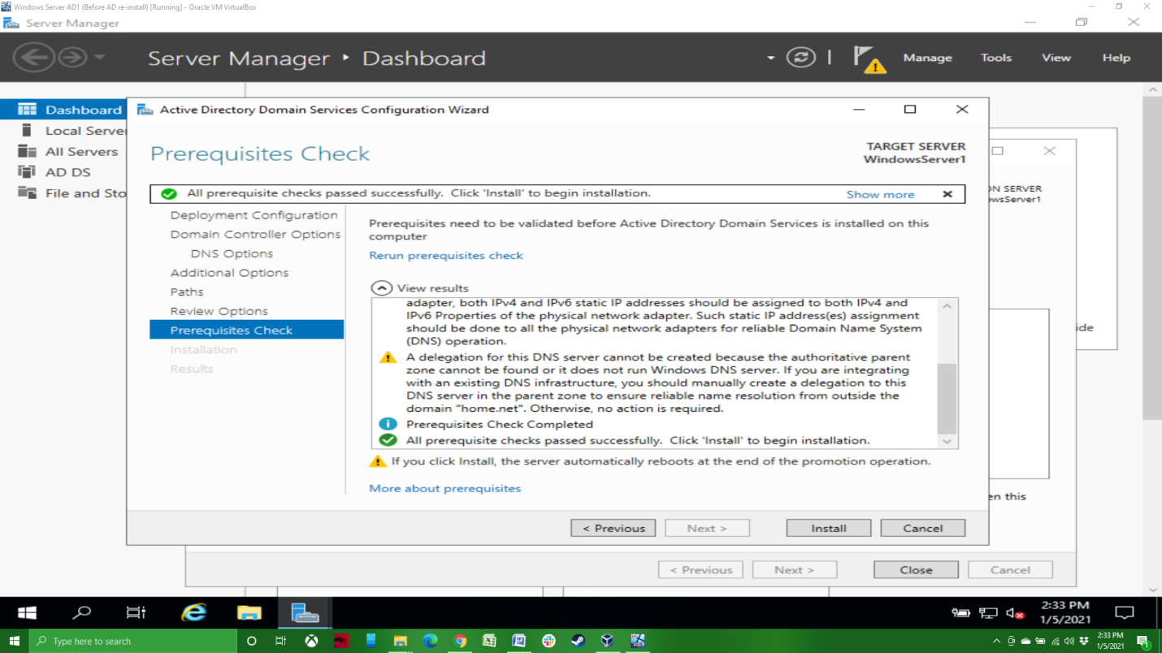

You should notice that the login screen is now different, showing the domain and user name.

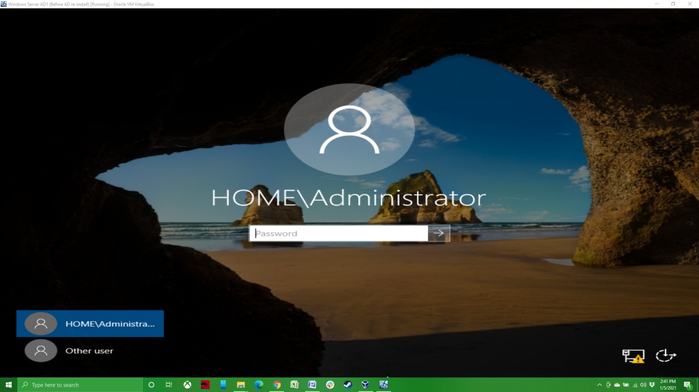

After logging in, you should see AD DS and DNS listed in the left side of the Server Manager screen.

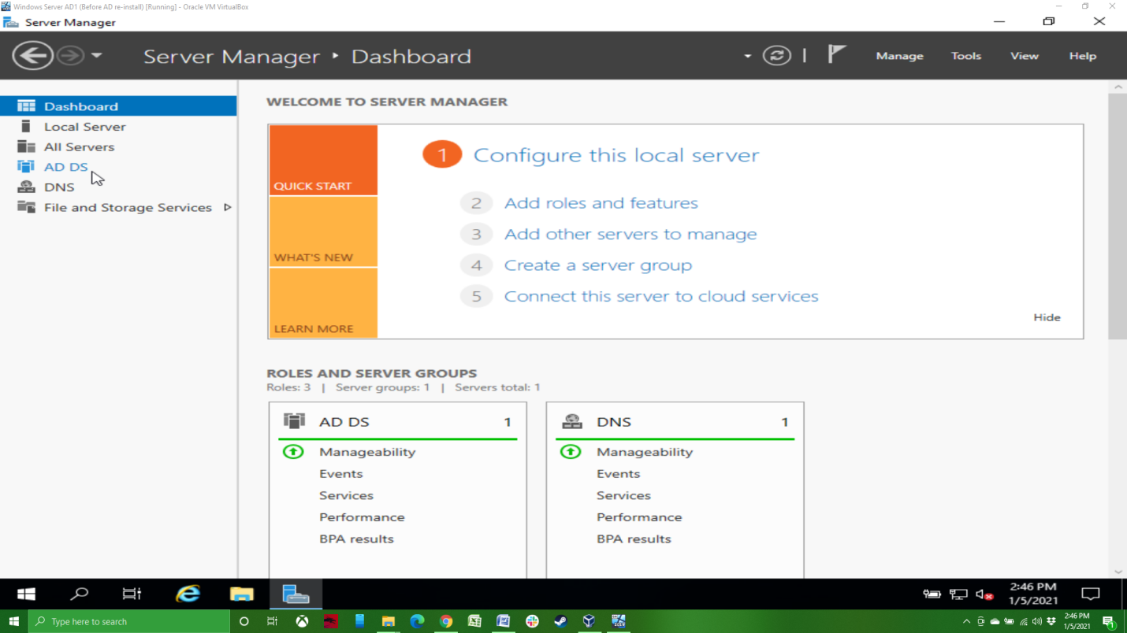

Also, if you go to the system information screen, you should notice that the Full computer name and Domain have been updated. This completes the basic set up for AD and DNS.

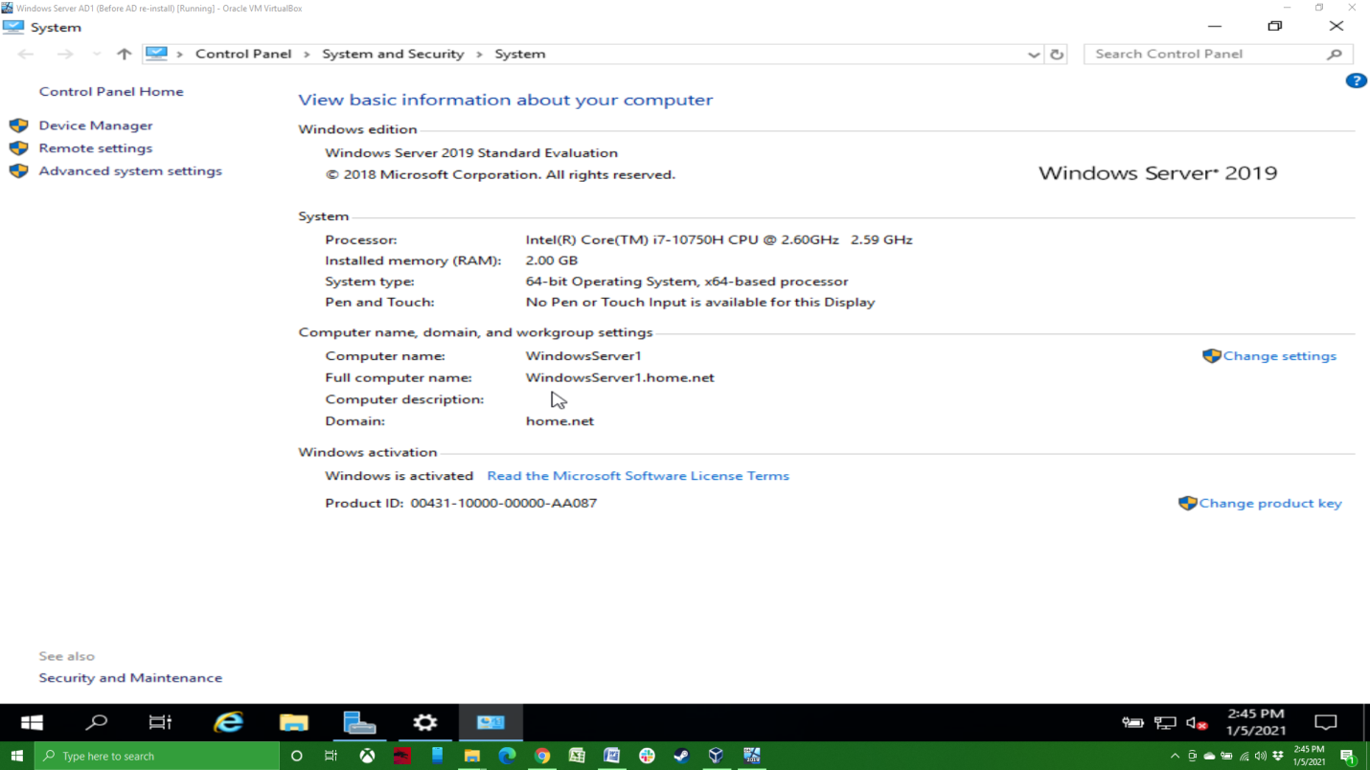

Moving on to DHCP, we’re going to start the same way by going to “Manage” in the upper right of the screen, then “Add Roles and Features”. Clicking through to Server Roles, we’ll click on the DHCP Server check box, add the feature, and click next before finally installing it.

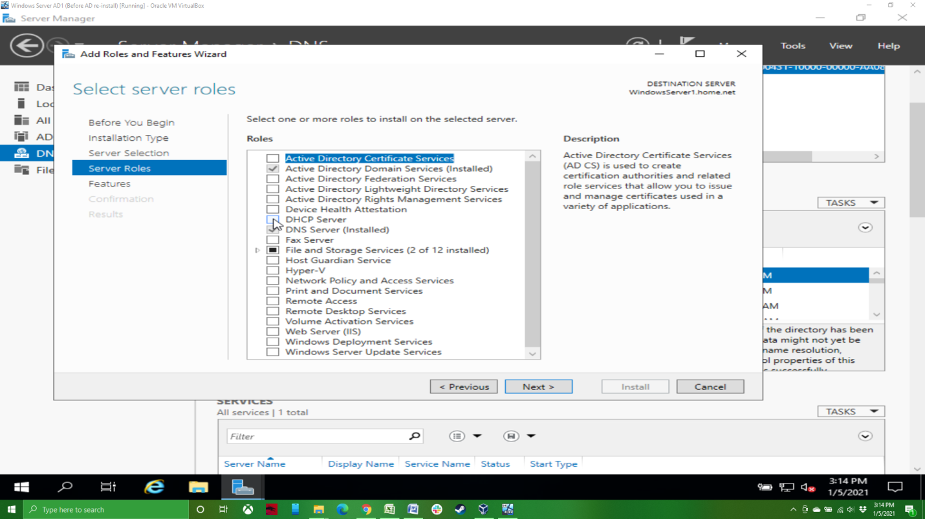

After the installation is complete, click on “Complete DHCP configuration”. You can click next and then close through the next few screens.

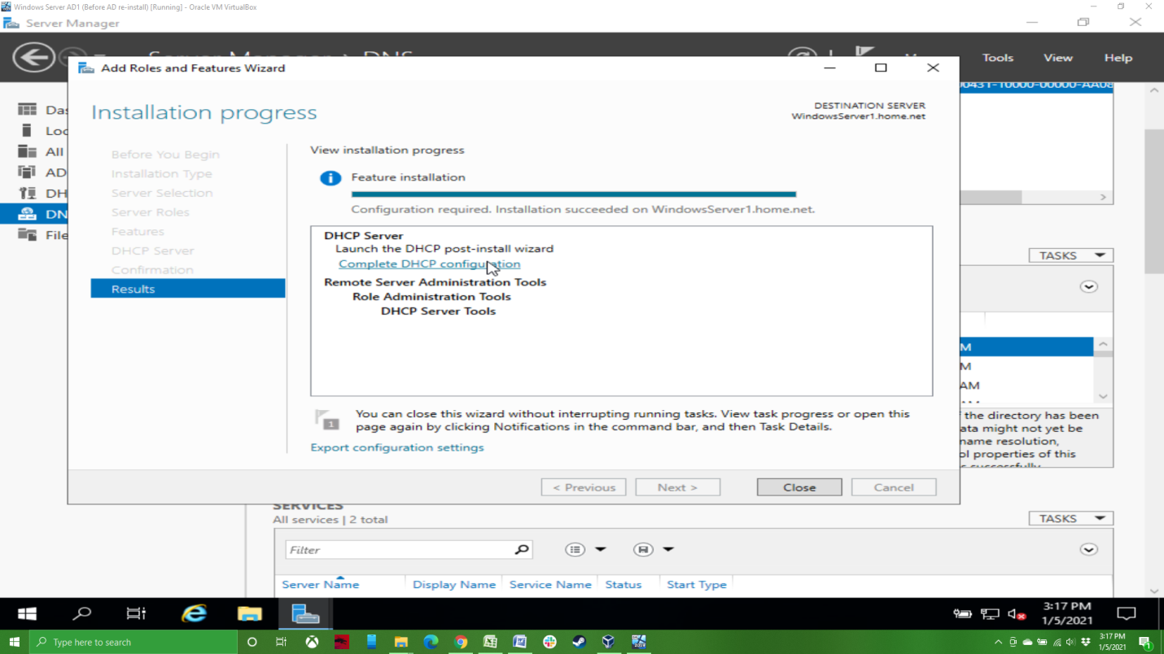

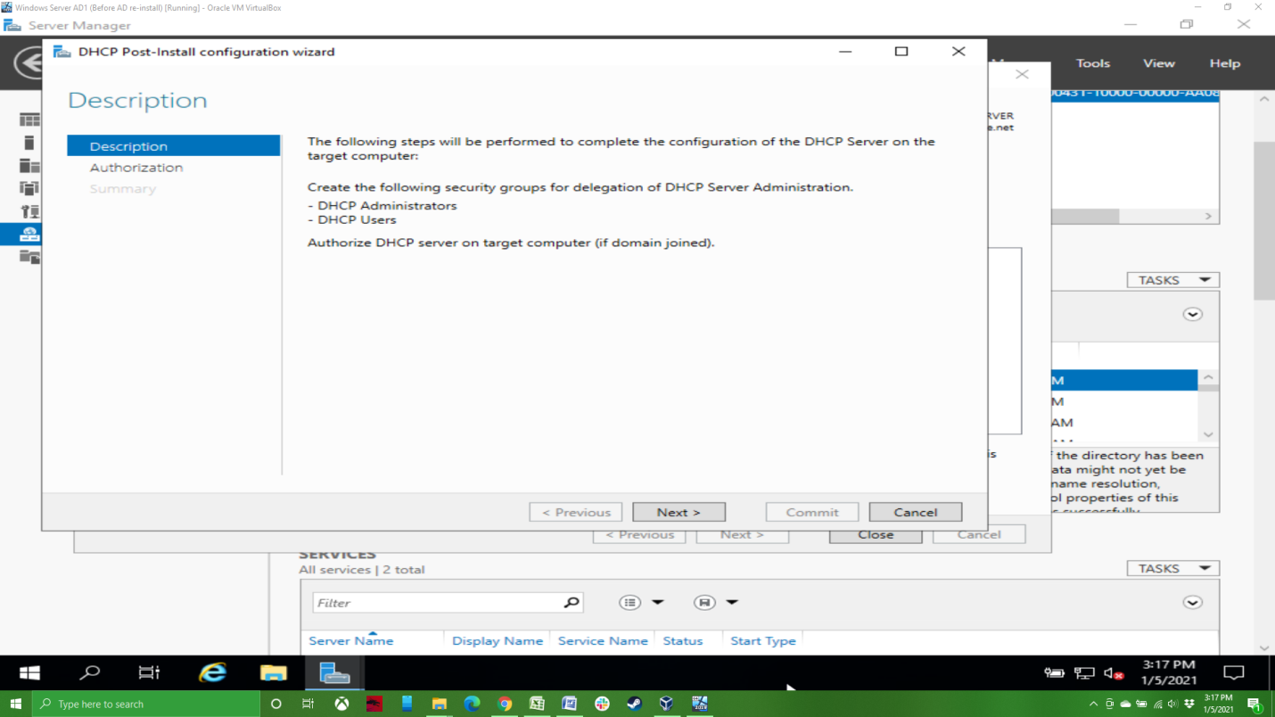

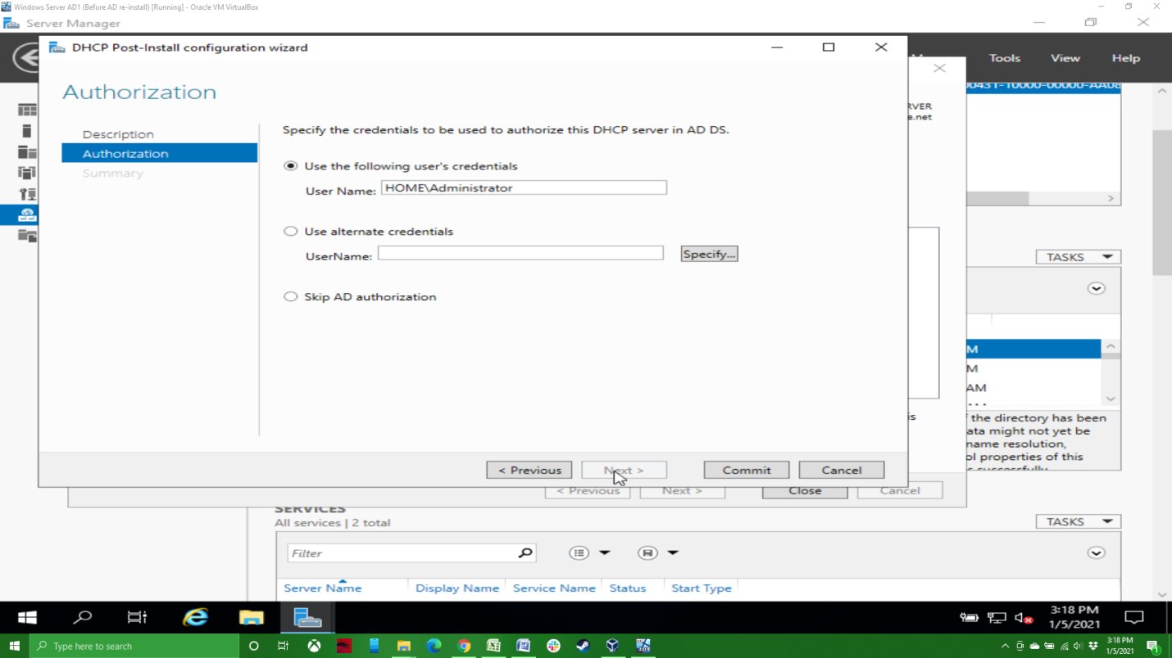

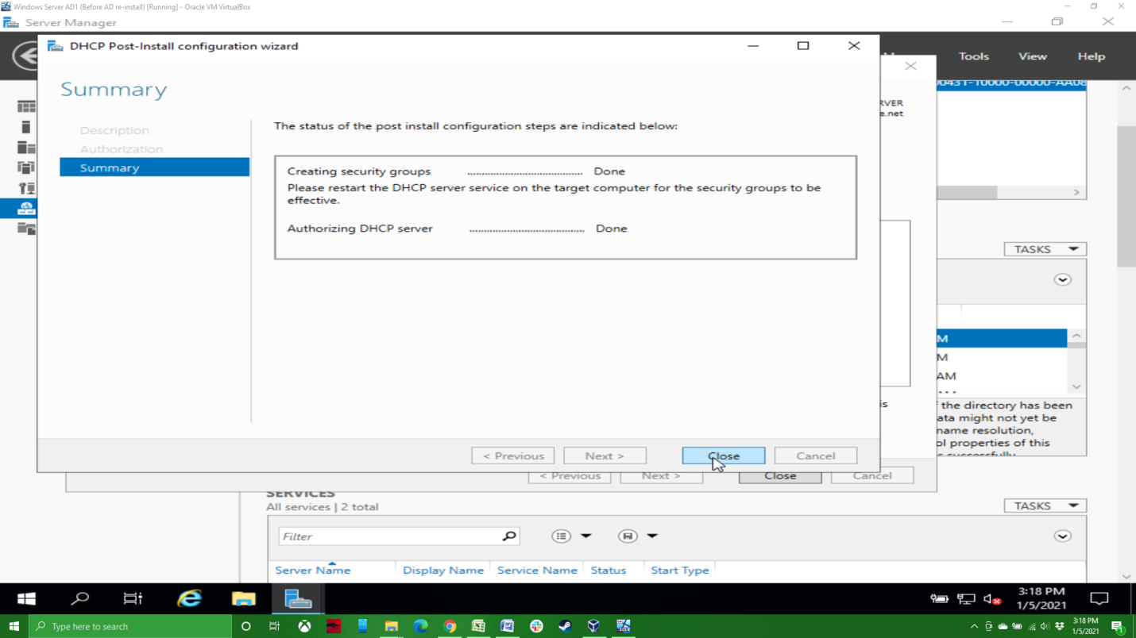

I restarted the server at this point, though you don’t necessarily need to. You should now see DHCP listed on the left side of the Server Manager. We now need to configure the DHCP scope. Since I’m using this server for a simple test environment, I’m going to set up a simple /24 network with only part of available addresses as part of the DHCP scope.

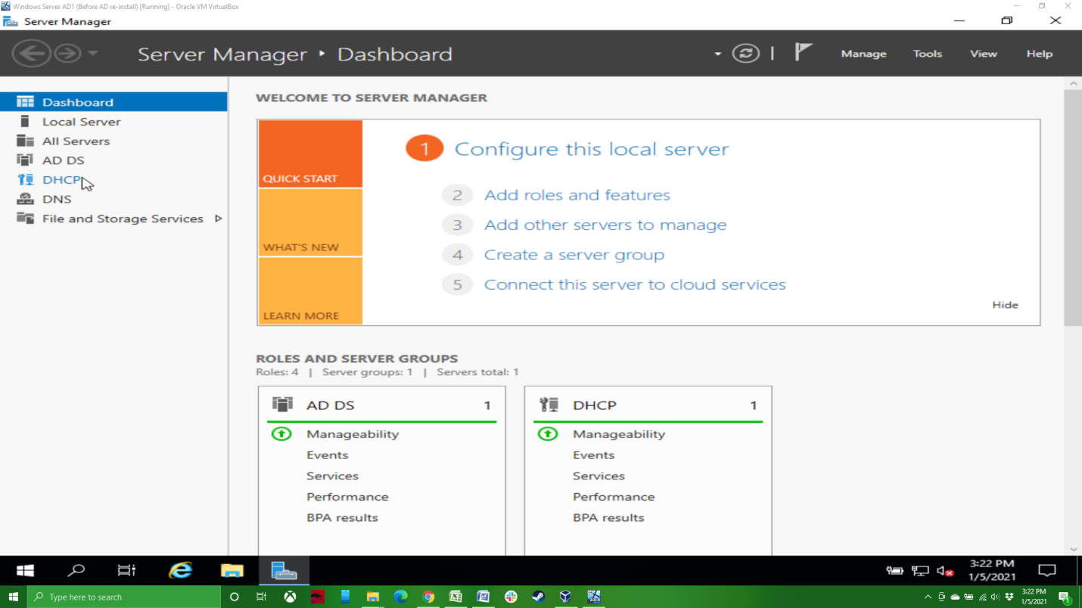

To start, click on “Tools” in the upper right of the screen, the on “DHCP”.

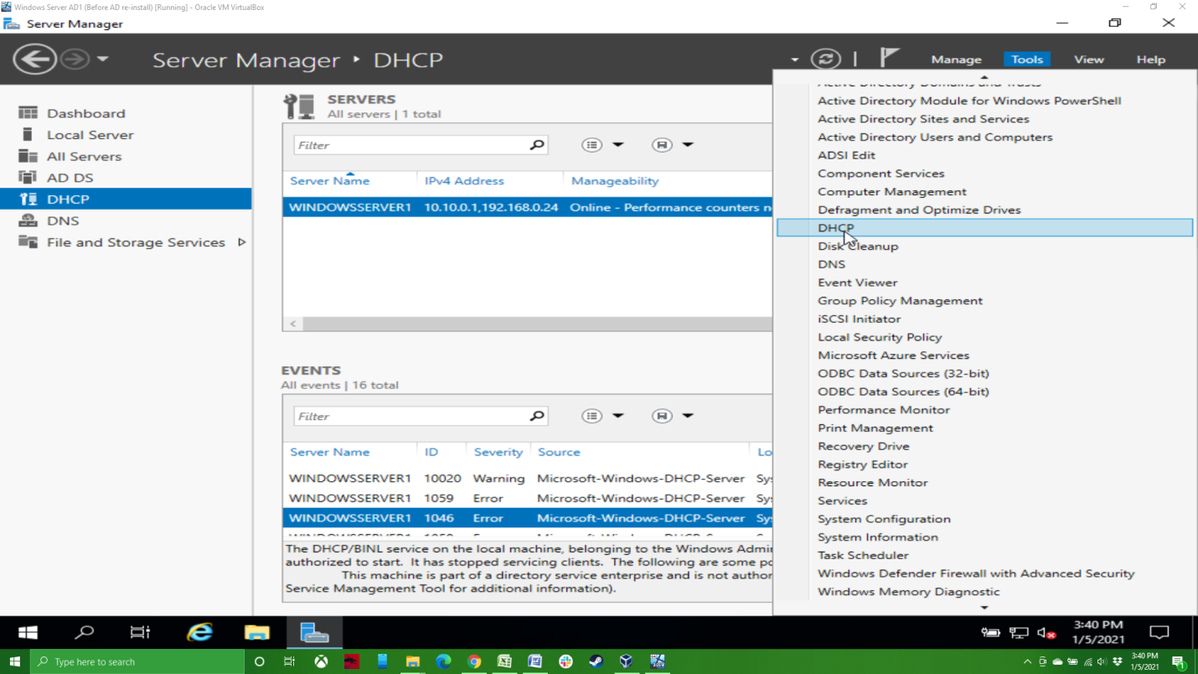

This will bring you to the DHCP management page. Click on the server.

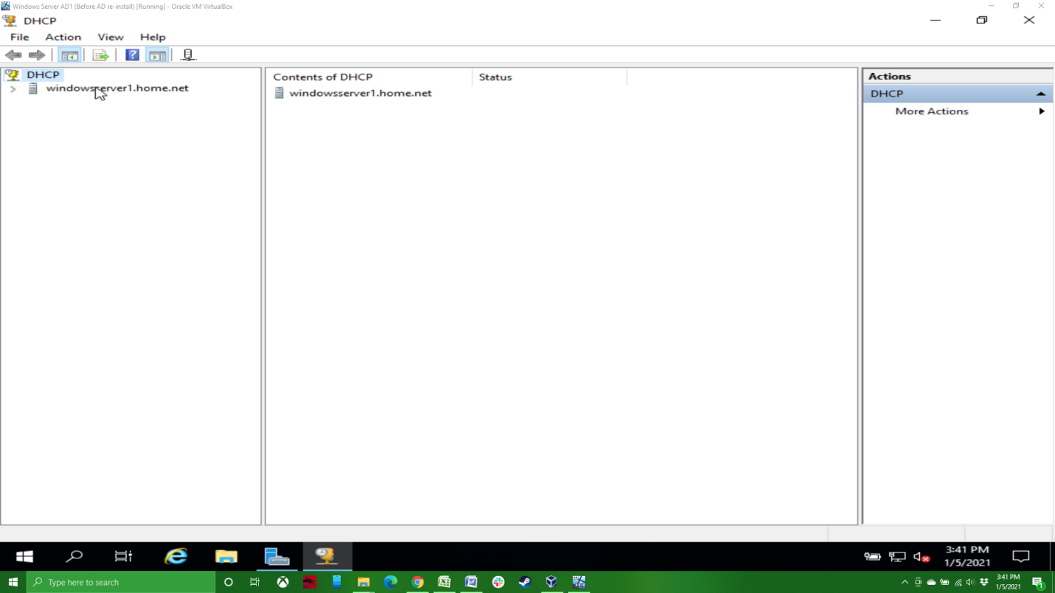

Right click on “IPv4”.

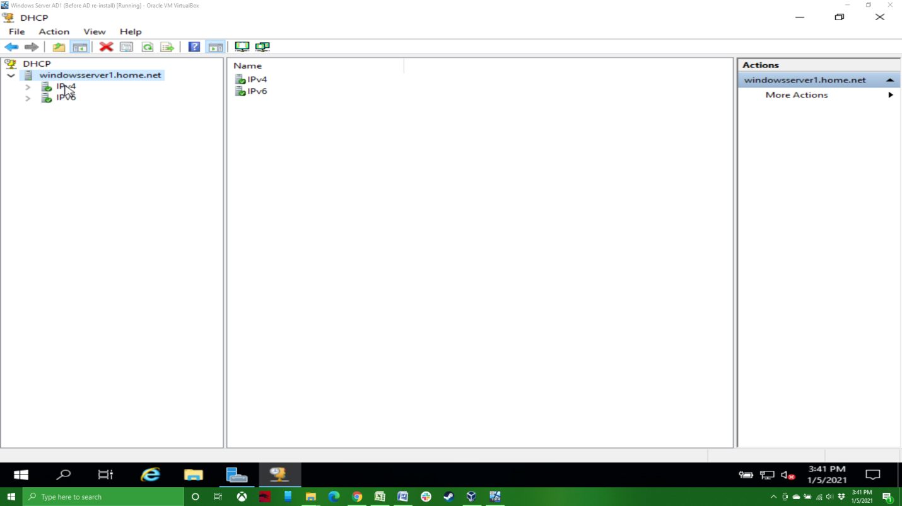

Then click on “New Scope”.

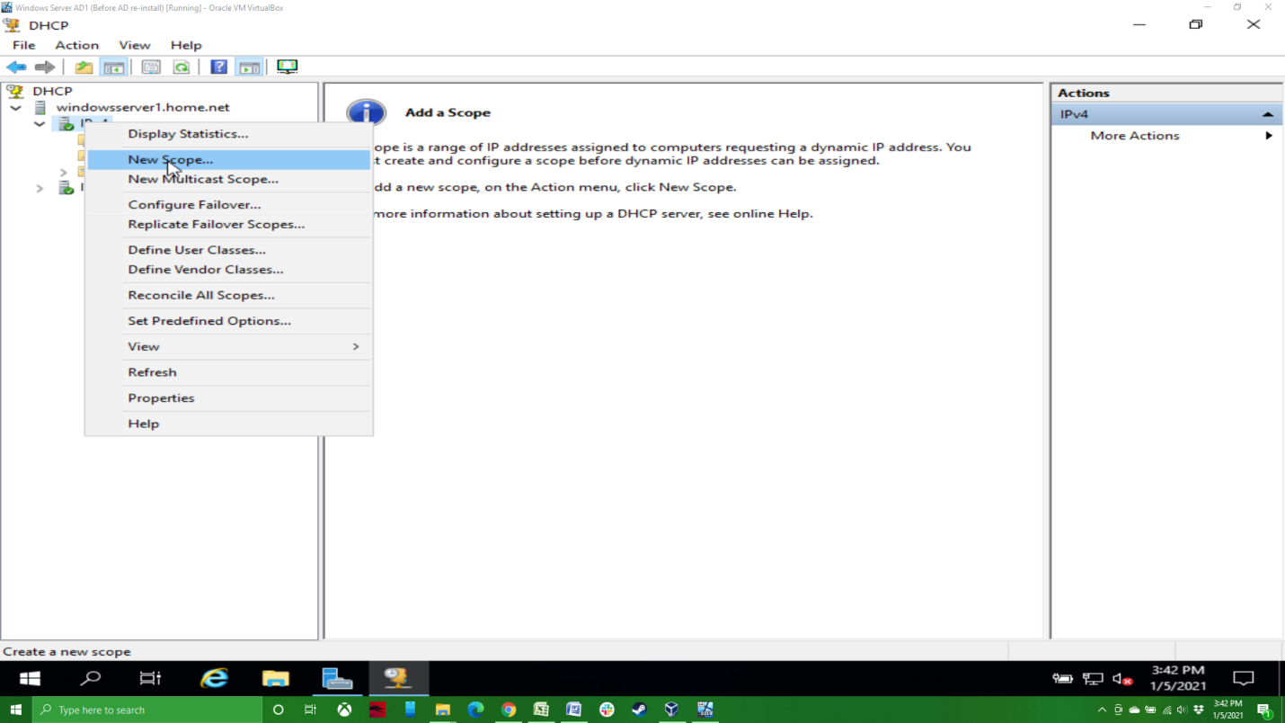

This will bring up the New Scope wizard, click next.

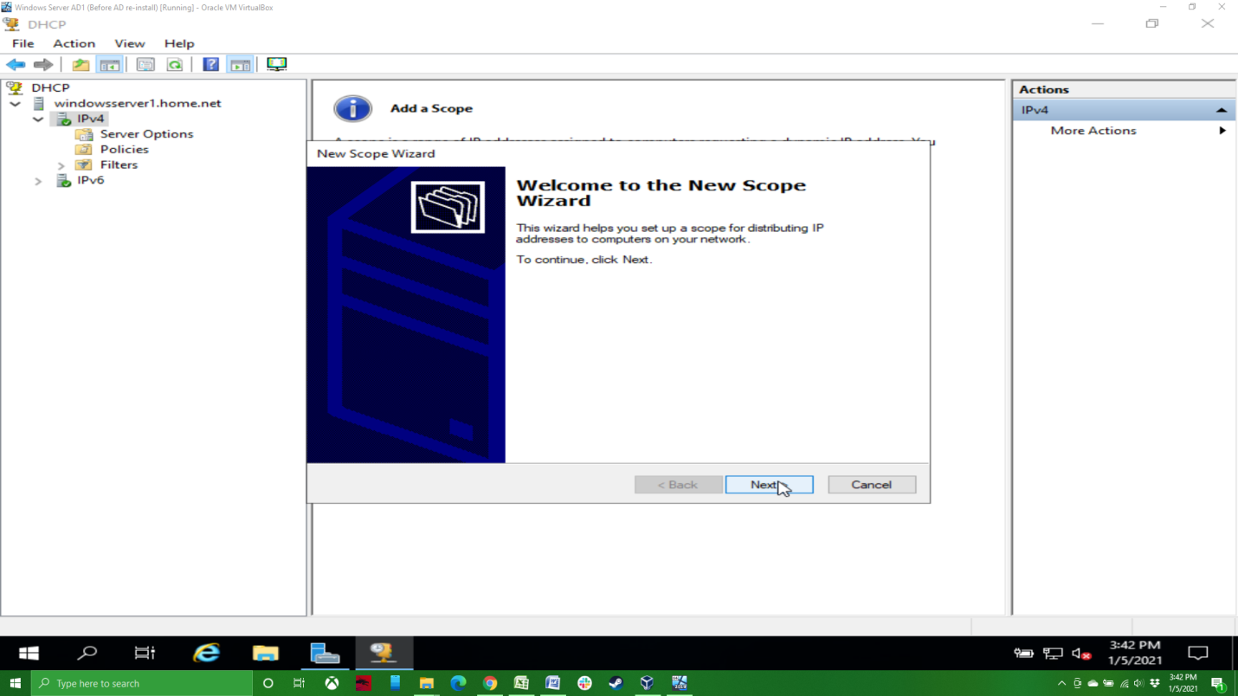

Give your scope a name and click next. In a complicated network environment, a good description of the scope is recommended.

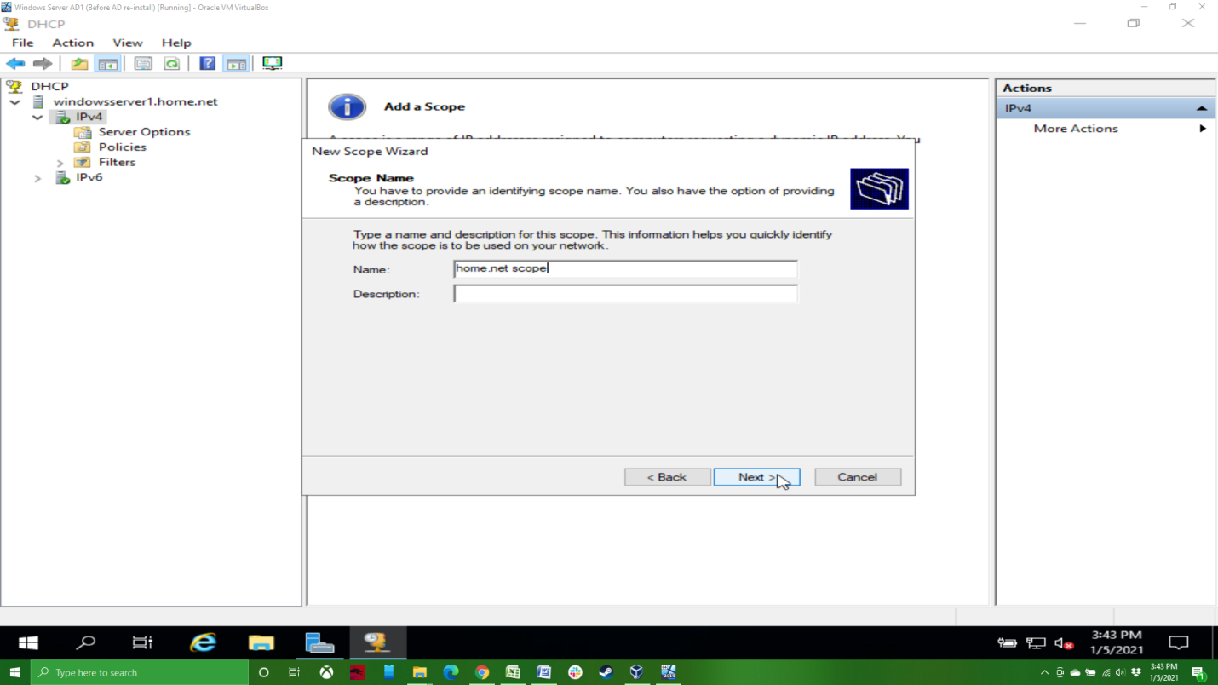

Next we’re going to set the IP range for the scope as well as the subnet. As you can see, I’ve set the range to be from 10.10.0.100 to 10.10.0.200, so 101 available IP address in the DHCP scope. I’ve also set the subnet to 255.255.255.0. You’ll notice that as you change the length variable, the subnet mask will change automatically.

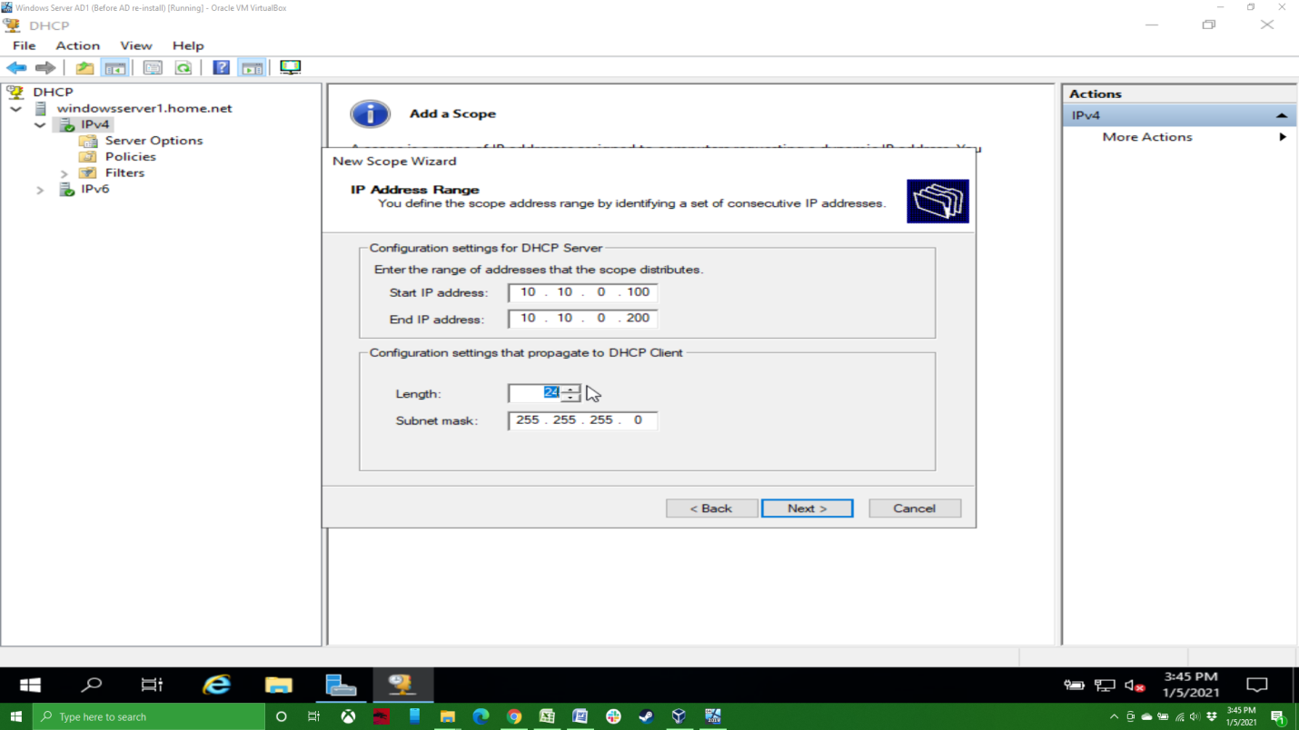

For our simple network, you can just click next here as we’re not going to add any exclusions or delays.

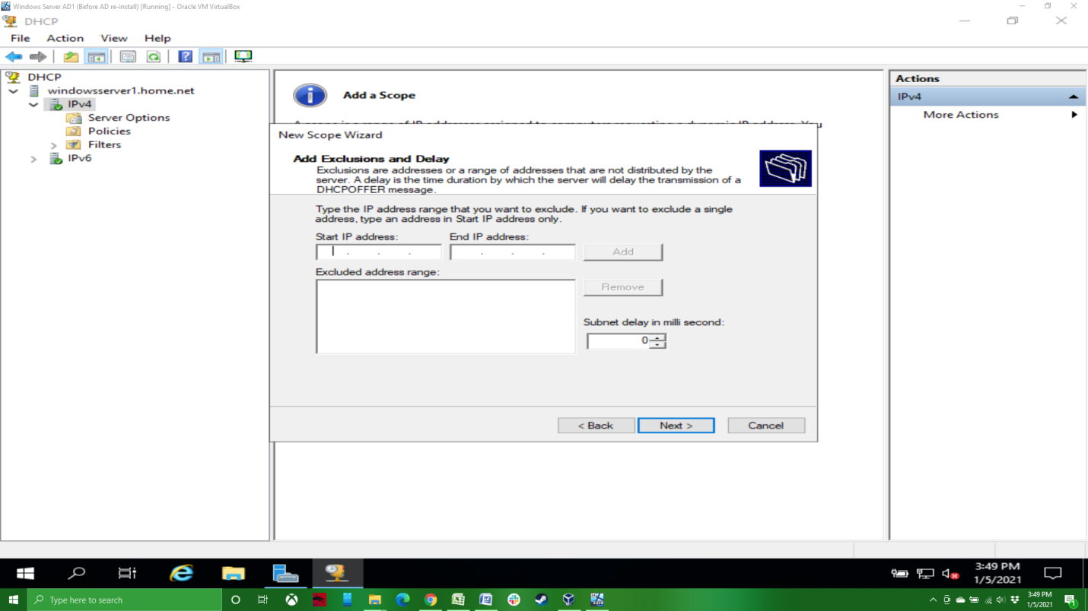

For out simple network, the lease duration isn’t particularly important (I set mine to 7 days), but in a real world environment this is an important setting. If you’re in a pretty static environment where there aren’t lots of new devices coming and going from the network, you can set this to be fairly long (days), but if you’re in an environment where different devices are joining and leaving the network with regularity, such as the guest network at your local coffee shop, you’ll want to set this quite a bit shorter (hours).

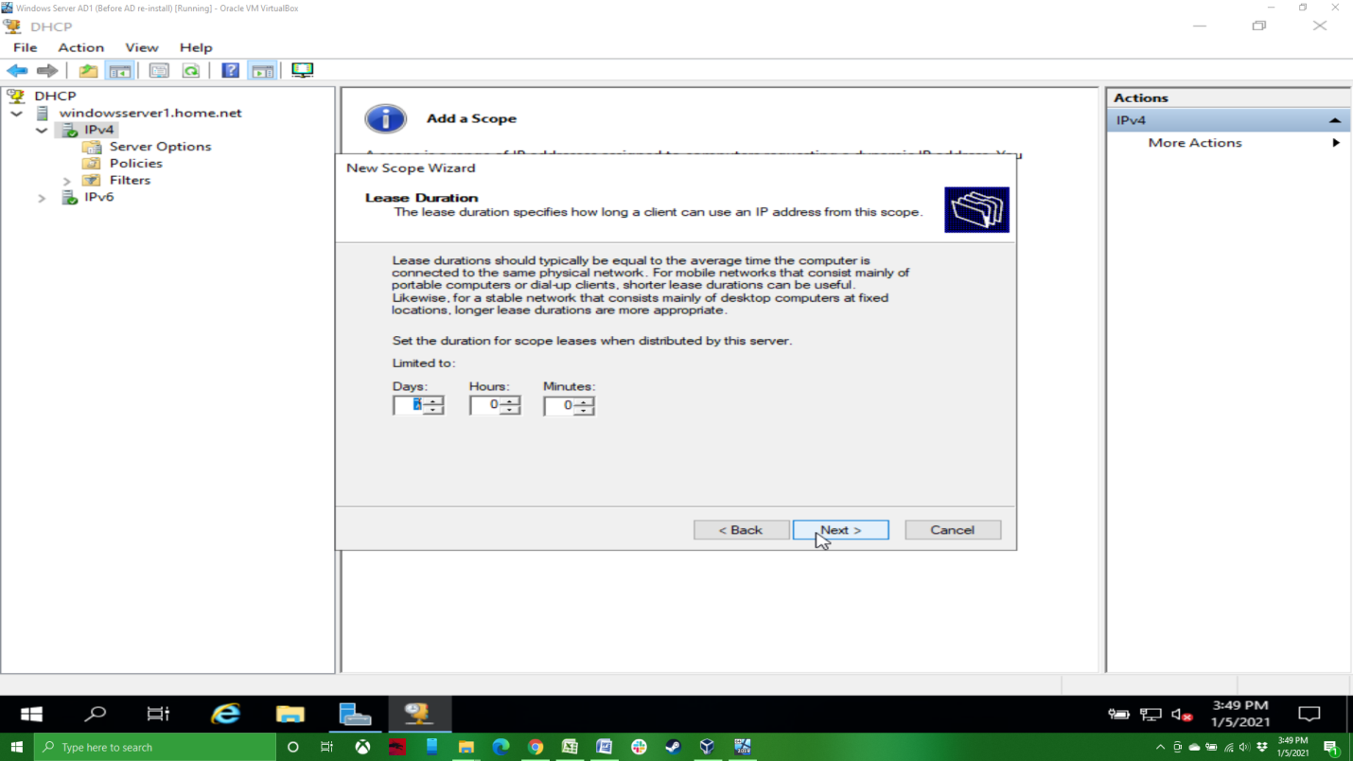

We do want to configure our options now, so click “Yes” and next.

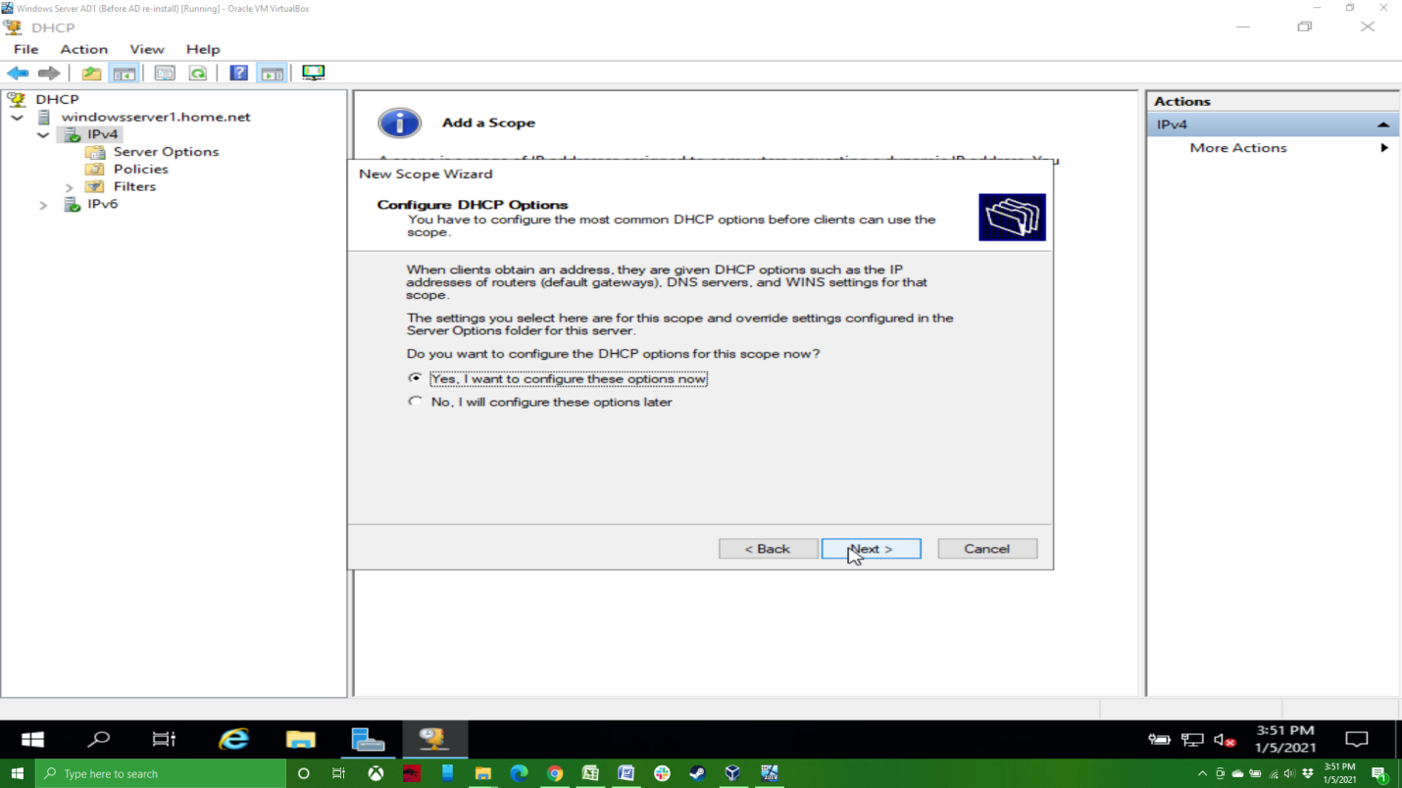

Add the IP address of your default gateway.

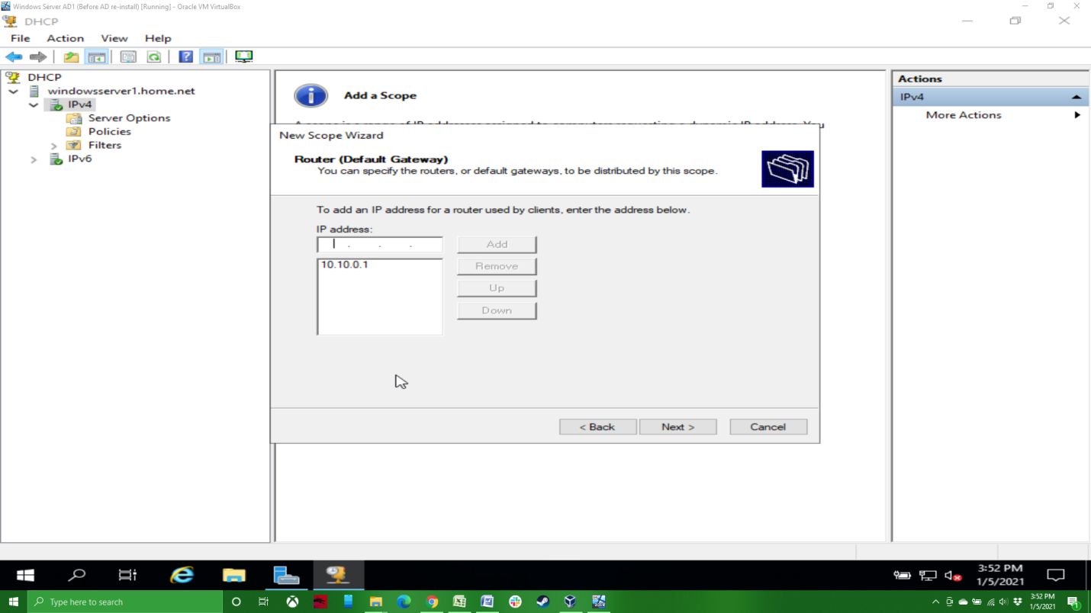

Add the IP address(s) of your DNS server(s).

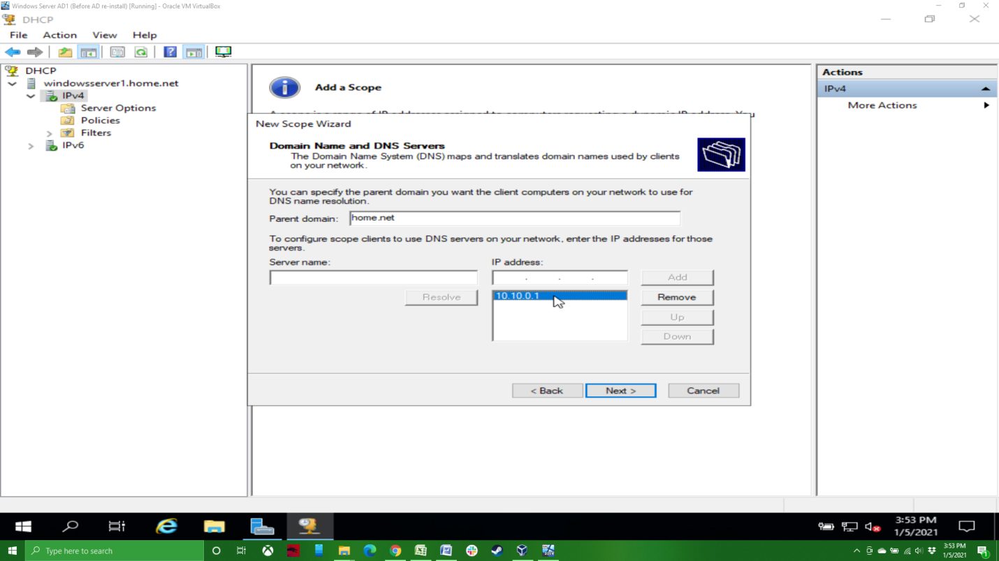

If you needs WINS server(s), add them here (you likely won’t).

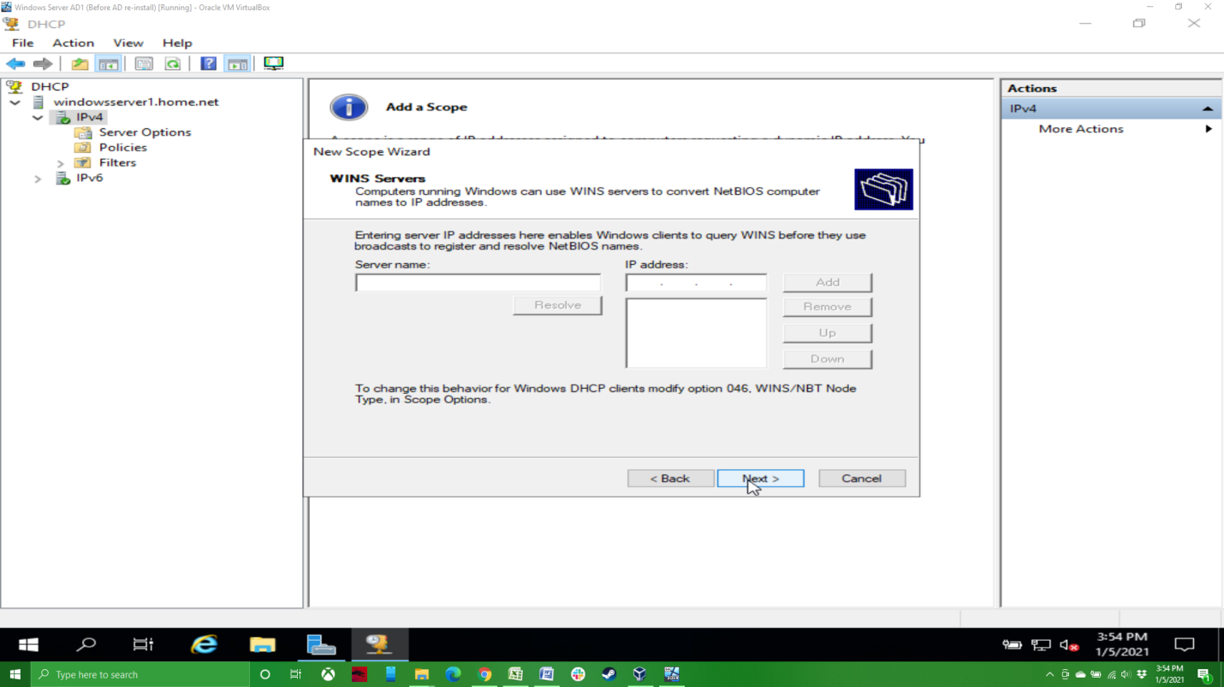

Yes, we want to activate the scope.

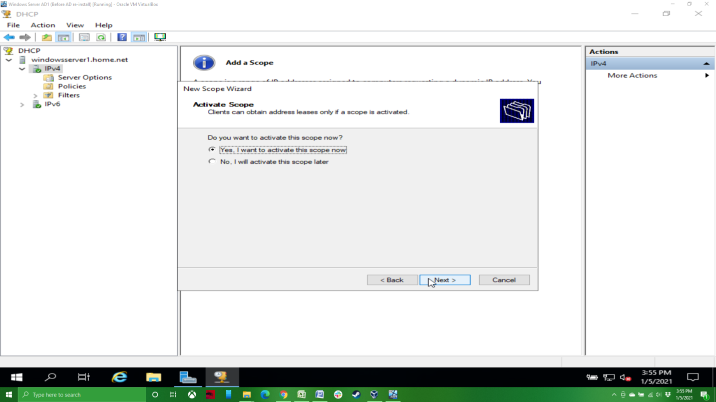

And with that, we’re done with our basic DHCP setup.

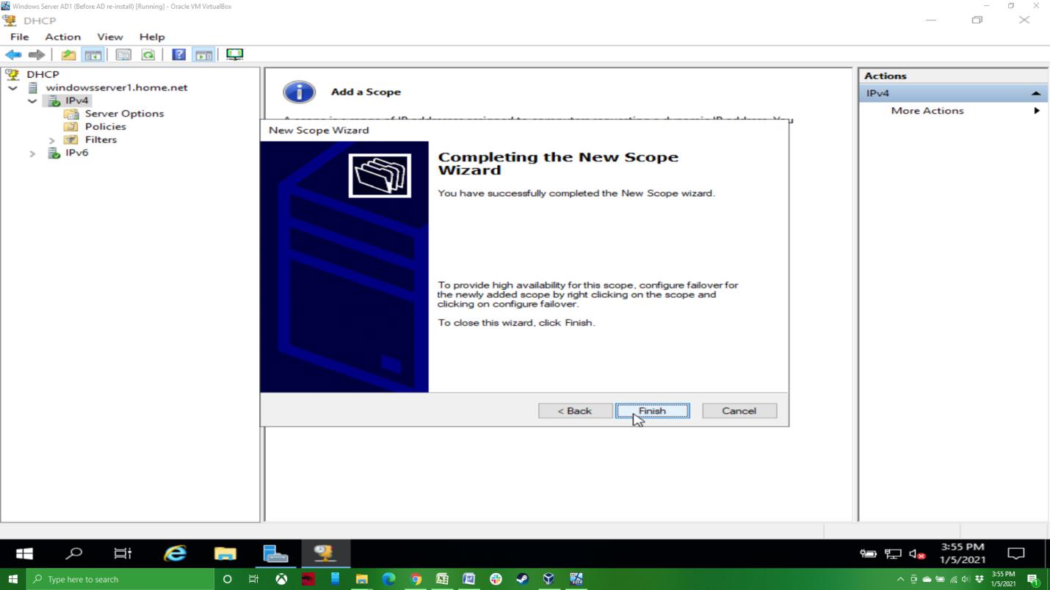

Back on our DHCP management screen, we can now see the scope that we’ve added.

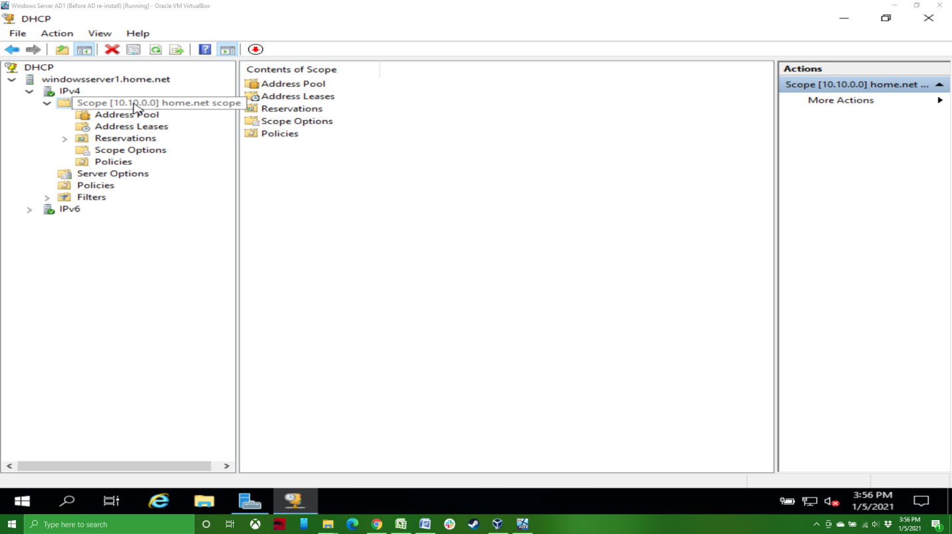

Next time, we’ll add a secondary Active Directory server to the domain, as well as a Windows 10 system. I want to give a shout out to Eli the Computer guy, who has a great series of videos on YouTube around setting up Active Directory and a great many other topics. You can find his YouTube channel here: <https://www.youtube.com/channel/UCD4EOyXKjfDUhCI6jlOZZYQ>.